The way to use TFTP upgrade firmware (Only for Windows)

Trouble: 1. Router can’t into WEB interface

2. Router can’t normal start.

Sept 1.Download the latest firmware of your router from netis-systems.com to your computer.

Sept 2.Download the TFTP program. (Used WIN 7 32-bit computer and tftpd32 as example)

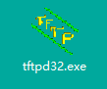(For example)

Sept 3: Double Click **TFTP32.exe**

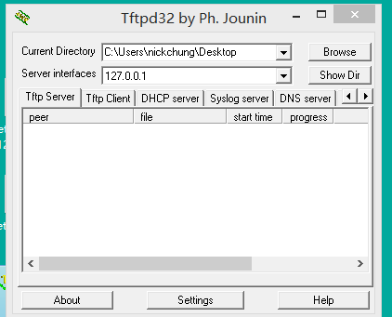

Sept 4: Configure a static IP address of wired adapter 192.168.1.5 on your computer. Make sure you disable or turn off your wireless adapter.

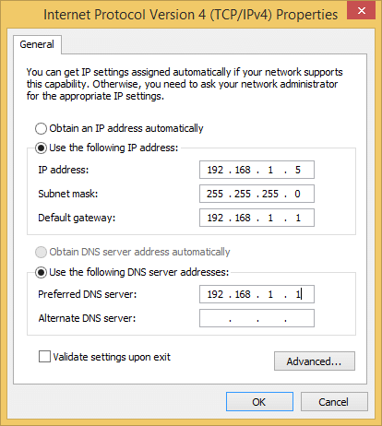

Sept 5. Connect router LAN4 to your computer’s wired adapter with a wired cable.

Sept 6: Holding the **reset/default** button before plug in power adapter. wait 2~3 seconds, release **reset/default** button. The router will go into boot mode. Only the LAN4 and Power LED are flashing.

Sept 7: Setting the tftpd32.exe

1. Current Directory: default state
2. Server interface: will automatically detect your computer IP address (192.168.1.5), just need waiting several seconds.

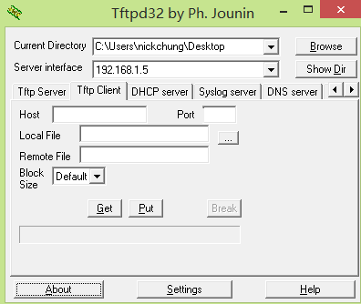

1. Select Tftp Client: Host: input 192.168.1.6

Local file:Seclect the Download firmware file（In step 1）

Other don’t need input.

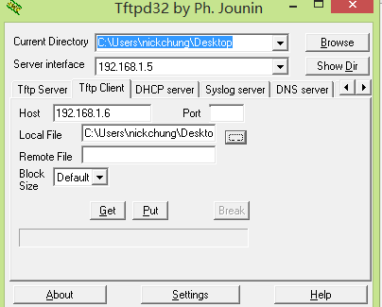

1. Click put

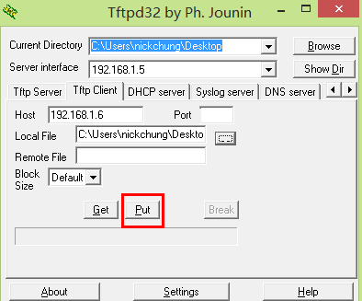

1. Upload successful.

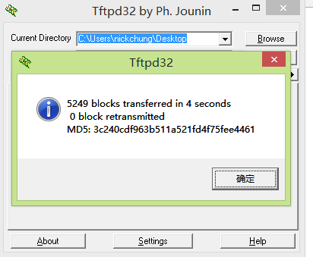

1. Waiting 1~2 minute, Until see the all lights flashing, turn off power adapter

Step 7: Check whether upgrade successful.